MP0

Table of contents

1. Topic: ShaReCon Inc.
2. [Model (E-R)](#_Model_(E-R))
3. *Employee* table
4. *Project* table
5. *Customer* table

# Topic: Online Shop

ShaReCon Inc. need a project management system for employees to display and manage past, on-going and future projects

# Model (E-R)

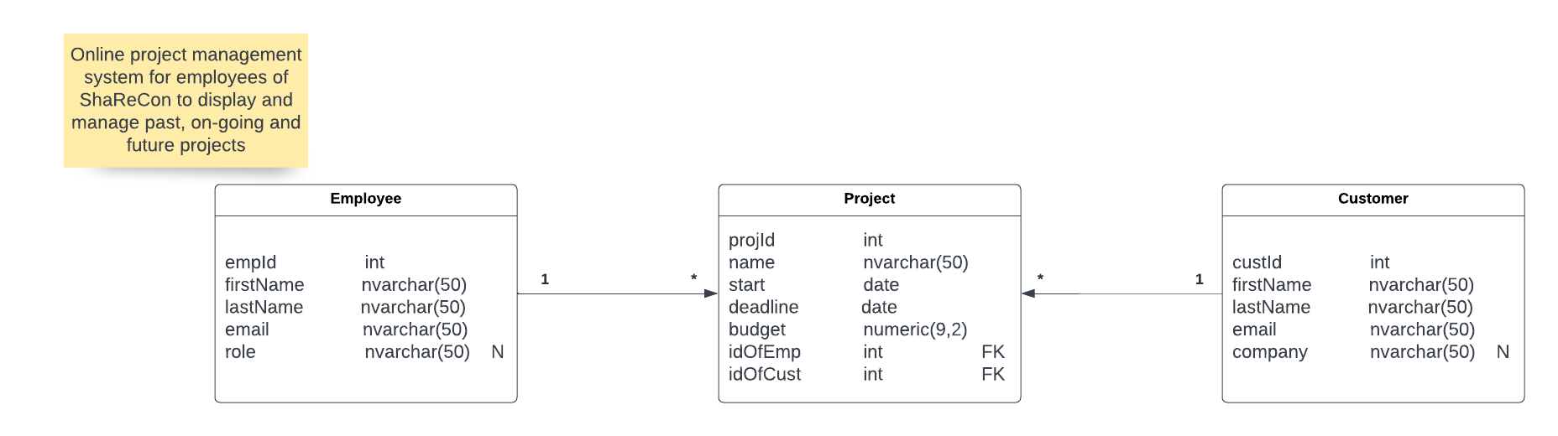

## *Employee* table

|  |  |  |  |
| --- | --- | --- | --- |
| **Field name** | **Type** | **Required** | **Description** |
| empId | integer | Yes | Primary key |
| firstName | nvarchar | Yes | Employee’s first name |
| lastName | nvarchar | Yes | Employee’s last name |
| email | nvarchar | Yes | Contact to the employee |
| role | nvarchar | No | Role in the company ex. Senior React Developer |

## *Project* table

|  |  |  |  |
| --- | --- | --- | --- |
| **Field name** | **Type** | **Required** | **Description** |
| projId | integer | Yes | Primary key |
| name | nvarchar | Yes | Project name |
| start | date | Yes | Start date of the project |
| deadline | date | Yes | Deadline for the project |
| budget | numeric | Yes | Estimated budget for the project |
| idOfEmp | integer | Yes | Foreign key – *Employee* table |
| customer_id | integer | Yes | Foreign key – *Customer* table |

## Customer table

|  |  |  |  |
| --- | --- | --- | --- |
| **Field name** | **Type** | **Required** | **Description** |
| custId | integer | Yes | Primary key |
| firstName | nvarchar | Yes | Customer’s first name |
| lastName | nvarchar | Yes | Customer’s last name |
| Email | nvarchar | Yes | Contact to the employee |
| Company | nvarchar | No | Company the customer is working for |